[11.5] I believe deant provided a correct solution to this problem, but he made some mistakes in explaining it. For example, in his figure he claimed that his side A gets rotated into his side C, and that is clearly not correct because those sides in his figure are definitely not the same size. I am making a pass at clarifying his explanation.

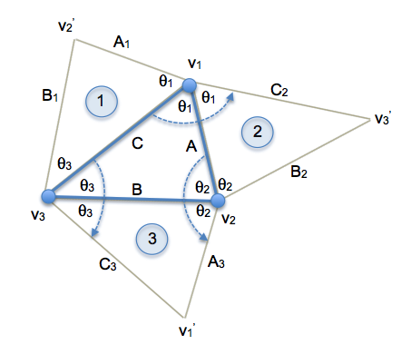

Consider 2 rotations about different axes. Let vertices v1 and v2 be the two axes of rotation with angles of rotation 21 and 22, respectively, in the directions shown in the figure. By halving the angles, we create the blue triangle <v1 v2 v3> with sides A, B, and C. Next we create triangles 1, 2, and 3 as shown by reflecting this triangle about sides C, A, and B, respectively.

It is easy to see that 21 rotates triangle 1 into triangle 2, sliding side A1 into A, B1 into B2, and C into C2. (Sides A1 to A and C1 to C are easy to visualize, and since that fixes all 3 vertices, then slide B2 must also match up.) Similarly 22 rotates triangle 2 into triangle 3 with the respective sides matching up. Thus the composition rotates triangle 1 into triangle 3. Finally, we also see that 23 rotates triangle 1 into triangle 3, and thus v3 is the resultant axis of rotation and 23 is the rotation amount.